

**SOFTWARE REQUIREMENT SPECIFICATION (SRS) SIGN-OFF**

**Authorization Memorandum**

This form is to sign-off completion of the Requirement Phase for **CAMPUS MANAGEMENT SOFTWARE AT WORLD SKILL CENTER (WSC).**

World Skill Centre (WSC) acknowledges receipt of the deliverables as part of the Requirement Phase through the submission of this document.

|  |  |
| --- | --- |
| **MODULE NAME** | **Rewards and Achievments** |

| **VERSION HISTORY** | | | |
| --- | --- | --- | --- |
| **Version** | **Author** | **Date** | **Changes** |
|  |  |  |  |
|  |  |  |  |

**WSC AUTHORITY NAME AND**  **SIGNATURE**

**SOUL AUTHORITY NAME AND**  **SIGNATURE**

Pages 1 of 7



# Logo Description automatically generated未标题-1

**Sustainable Outreach And Universal**

**Leadership (SOUL) Limited**

**Software Requirement Specification (SRS)**

Of

**Rewards and Achievments**

For Implementation of

**Campus Management Software**

at

**World Skill Center (WSC)**

**Table of Content**

A. Abstract 3

B. Introduction 3

C. Definition, Acronyms and Abbreviations 3

D. Overview of the Document 3

E. Scope of Education Module 4

F. WSC Infrastructure Management & Maintenance Process Flow 4

G. Process Flow Description 4

H. List of Screen and their descriptions 4

I. Rewards & Achievments 6

# Abstract

Software Requirements Gathering is one of the first phases of system development. This phase results in the Software Requirements Specification (SRS) document, which must contain a complete, concise, high-quality description of the system being considered.

# Introduction

The World Skill Center (WSC) is a premier advanced skill training institute established by the Government of Odisha, Skill Development and Technical Education Department, through the Odisha Skill Development Authority (OSDA). The WSC will impart advanced skill training in eight trades from engineering and service sectors. WSC caters primarily to induct the best talent from ITIs and Polytechnics and train them to become globally employable in emerging areas such as "Industry 4.0". WSC is housed in a state-of-the-art, 18-storey, air-conditioned building with nearly half a million square feet of space in the heart of capital city of Bhubaneswar.

With the Implementation of campus management software for WSC the goal is to streamline the operations and functions of the campus by integrating various processes, such as admissions, course registration, academic progress tracking, and financial management, HRMS, Procurement and Inventory management, etc into a unified system. The implementation also aims at providing a user-friendly interface for all stakeholders, making it easier for them to access the necessary information and complete their tasks with ease. The modules to be covered during the implementation of the software includes:

|  |  |
| --- | --- |
| Students Management Modules | Infrastructure Management |
| Academic System | Finance and Accounting System |
| Procurement & Inventory Management | Training and Placement |
| Human Resources Management System | Application Integration |

# Definition, Acronyms and Abbreviations

The following table explains the terms and abbreviations used in the document:

|  |  |
| --- | --- |
| **Abbreviation** | **Description** |
| SRS | Software Requirements Specification |
| NA | Not Applicable |

# Overview of the Document

This requirement document provides a detailed overview of the functional requirements of a project. It serves as a communication tool between stakeholders, including developers, project managers, and end-users. The purpose of this requirement document is to define and document the project's objectives, scope, and expectations, and to ensure that all stakeholders have a clear understanding of what the project entails.

This document covers all the functional requirements of the **Rewards & Achievments module** of ERP Product. This module helps in maintaining as well as fetching records of meritorious students from any given program and semester so as to reward them.

# Rewards & Achievments

**General Description**

|  |  |
| --- | --- |
| **Description** | This screen will assist the user in fetching students based on merit as well as any cutoff grade points ie. fetching students between any given upper and lower grade point.  The list will be in Rankwise order with the ability to allocate any specific amount to the rank holders. |
| **Navigation** | NA |
| **Pre-requisites** | NA |

**Screenshot**

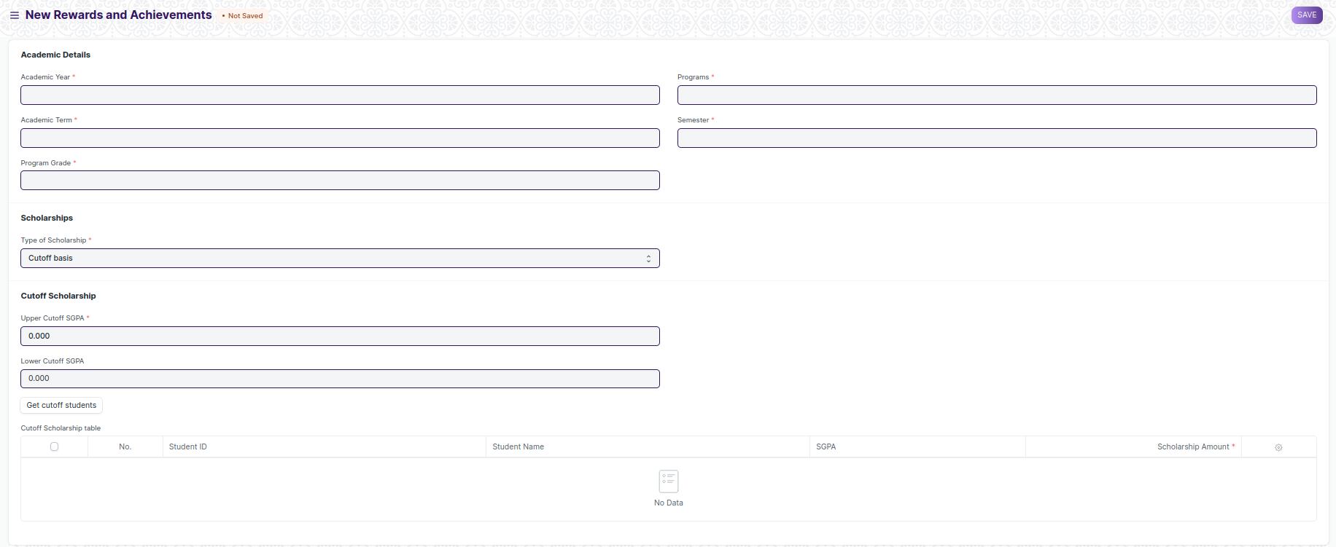

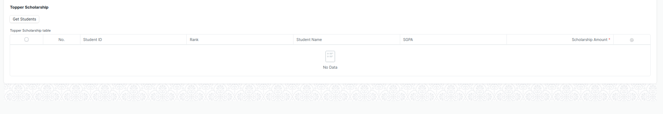

Figure 1: Rewards & Achievments Screen

**Field List**

The “Rewards & Achievments” screen shall consist of the following fields:

|  |  |  |  |  |  |
| --- | --- | --- | --- | --- | --- |
| **ID** | **Field Label** | **Field Type** | **Validation/Action** | **Mandatory** | **Remarks** |
| 1 | Academic Year | Link Field | Auto fetched from Academic Year | Y |  |
| 2 | Academic Term | Link Field | Auto fetched from Academic Term | Y |  |
| 3 | Program Grade | Link Field | Auto fetched from Program Grades | Y |  |
| 4 | Programs | Link Field | Auto fetched from Programs | Y |  |
| 5 | Semester | Link Field | Auto fetched from Program(semester) | Y |  |
| 6 | Type of Reward | Select | Merit basis  Cutoff basis | Y |  |
| 7 | Get Students | Button | On click of this button, students from above semester and program will be fetched with their ranks. |  |  |
| 8 | **Topper Scholarship table** | Table | Table described Below |  |  |
| 9 | Upper Cutoff SGPA | Number Field | Decimal values are acceptable |  |  |
| 10 | Lower Cutoff SGPA | Number Field | Decimal values are acceptable |  |  |
| 11 | Get cutoff students | Button | On click of this button, students between the mentioned cutoff will be fetched |  |  |
| 12 | **Cutoff Scholarship table** | Table | Table described Below | Y |  |

|  |  |  |  |  |  |
| --- | --- | --- | --- | --- | --- |
| **Topper Scholarship table** | | | | | |
| **ID** | **Field Label** | **Field Type** | **Validation/Action** | **Mandatory** | **Remarks** |
| 1 | Student ID | Text Field | Auto Fetched on the click of the button “Get Students” |  |  |
| 2 | Rank | Text Field | Auto Fetched on the click of the button “Get Students” |  |  |
| 3 | Student Name | Text Field | Auto Fetched on the click of the button “Get Students” |  |  |
| 4 | SGPA | Text Field | Auto Fetched on the click of the button “Get Students” |  |  |
| 5 | Amount | Currency | User Input | Y |  |

|  |  |  |  |  |  |
| --- | --- | --- | --- | --- | --- |
| **Cutoff Scholarship table** | | | | | |
| **ID** | **Field Label** | **Field Type** | **Validation/Action** | **Mandatory** | **Remarks** |
| 1 | Student ID | Text Field | Auto Fetched on the click of the button “Get cutoff students” |  |  |
| 2 | Student Name | Text Field | Auto Fetched on the click of the button“Get cutoff students” |  |  |
| 3 | SGPA | Text Field | Auto Fetched on the click of the button “Get cutoff students” |  |  |
| 4 | Amount | Currency | User Input | Y |  |

**Note:** This screen will fetch students based on the given required fields ie. Academic Year, Academic Term, Program Grade, Programs, and Semester. This screen fetch’s students in two types: based on merit(rank wise) and the other is based on the cutoff grade point which is defined by the user by giving inputs(Upper and Lower cutoff).

**User: Roles & Permission**

The following table describes the users and their roles and permissions for the screens:

|  |  |  |  |  |  |  |  |  |  |  |
| --- | --- | --- | --- | --- | --- | --- | --- | --- | --- | --- |
| **ID** | | **Role** | **Select** | **Read** | **Write** | **Create** | **Delete** | **Submit** | **Cancel** | **Amend** |
| 1 | Academics User | | No | Yes | Yes | Yes | Yes | NA | NA | NA |
| 2 | Education Admin | | Yes | Yes | Yes | Yes | Yes | NA | NA | NA |
| 3 | Instructor | | No | Yes | Yes | Yes | No | NA | NA | NA |
| 4 | Student | | Yes | Yes | No | No | No | NA | NA | NA |